Kingdom of Saudi Arabia
Ministry of Education
Course name : Ad hoc and Sensor Networks
Project Title : Ad Hoc IoT Network for Smart Device Discovery, Monitoring, and Remote Control

Table of contents

Contents
1. Introduction 3
2. Why we choose this title : 3
3. Architecture Diagram : 4
4. Tools : 4
5. Hardware : 5
6. Expected Outcomes : 5
7. Explanation of the code : 6
8. Screen shots : 6
9. Conclusion 8
10. Reference 8

- Introduction :
This project is a two-node Ad Hoc network built with Python over a direct Wi-Fi connection between two laptops, with no router or internet required. The Server listen for incoming connections, while the Client connects using the Server’s IP address. The nodes can sense each other’s presence, exchange real-time chat messages with Riyadh timestamps, remotely open the KFU Blackboard website on the Server using the /kfu command.

- Why we choose this title :
- Ad Hoc Network : using the important title of the course ( Ad Hoc ) .
- IoT Hoc Network : we wanted the project to feel like a real smart network where devices talk to each other on their own.
- Smart Device Discovery : met the requirements of the project, nodes sense each other automatically.
- Monitoring : our server on the project role as a monitoring point that watches who is connected.
- Remote Control : met the requirements of the project and it’s the key of IoT.

- Architecture Diagram :
The diagram below illustrates the architecture of the Ad Hoc network. Two laptops communicate directly over a Wi-Fi Ad Hoc connection. No router or internet is involved. The Server node listens on a fixed port and the Client connects it using the Server’s IP address.
💻 Laptop 1  Node: Server  HOST: 0.0.0.0  PORT: 50000  Python (socket, threading) | Wi-Fi Ad Hoc Link  ──────────────  TCP/IP | No Router  Port 50000  ──────────────  Chat | /chrome | /quit | 💻 Laptop 2  Node: Client  SERVER_IP: 192.168.x.x  PORT: 50000  Python (socket, threading)

- Tools :
- Programming Language : Python 3.x
- Socket module: Built-in library used to create TCP sockets for network communication between the two nodes.
- Threading module: Built-in library used to run message receiving and sending simultaneously on both nodes.
- Datetime module: Built-in library used to get current date and time for message timestamps.
- Pytz library: Third-party library installed via pip. Provides accurate time zone data for Riyadh
- VS Code / Terminal: Used as the development and execution environment on both laptops
- Wi-Fi Ad Hoc connection: The two laptops are connected directly via a Wi-Fi Ad Hoc connection. No router or internet required.
- Hardware :
Since this project is fully software-based with no physical IoT sensors the hardware is used:
- Laptops / PCs: Two laptops or PCs, each with a built-in Wi-Fi adapter
- Wi-Fi Connection: Both laptops connect directly to each other via Wi-Fi Ad Hoc, no router or access point needed

- Expected Outcomes :
Ad hoc network application will provide the following outcomes:
- The server will sense and display when a client joins or leaves the network.
- Both nodes will chat in real time with Riyadh timestamps on every message.
- The Server will remotely open KFU Blackboard on the Clints device by typing /chrome
- Either node can exit cleanly using /quit, notifying the other side instantly.
- If a node drops unexpectedly, the other node will detect and display the loss.
Overall, this project demonstrates a functional two-node Ad Hoc network that meets all three core requirements of the course project: sensing nearby nodes, sharing content, and remotely controlling a feature on a remote node.

- Explanation of the code :
Running the codes inside each device to give you the result needs all the environment of VS code we explained above.
There is a Clint side and Server side, both need to be open at the same time. Running the code with clint side for device number 1 and the other device run as a host.
Clint will see anything wrote by the server host on the terminal.

- Screen shots :
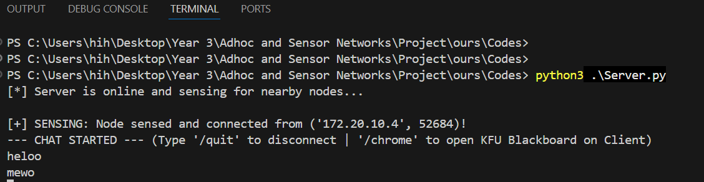
- As a server host, I wrote some messages for client device :

- The response from the client device :

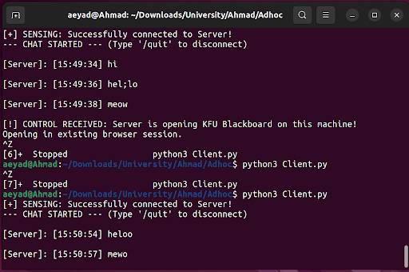

- Controlling on clint device remotely by open up KFU blackboard :
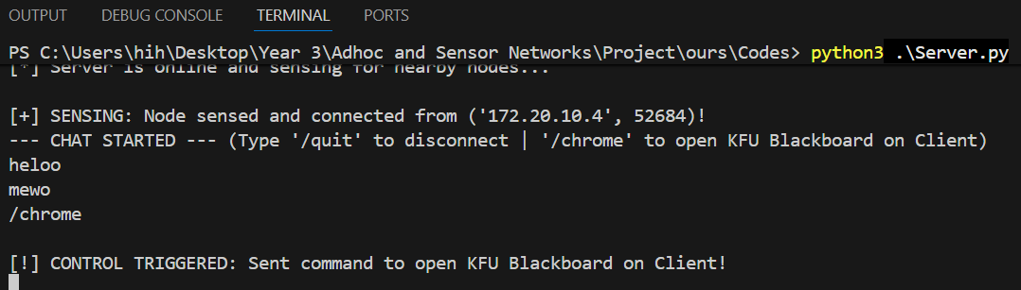

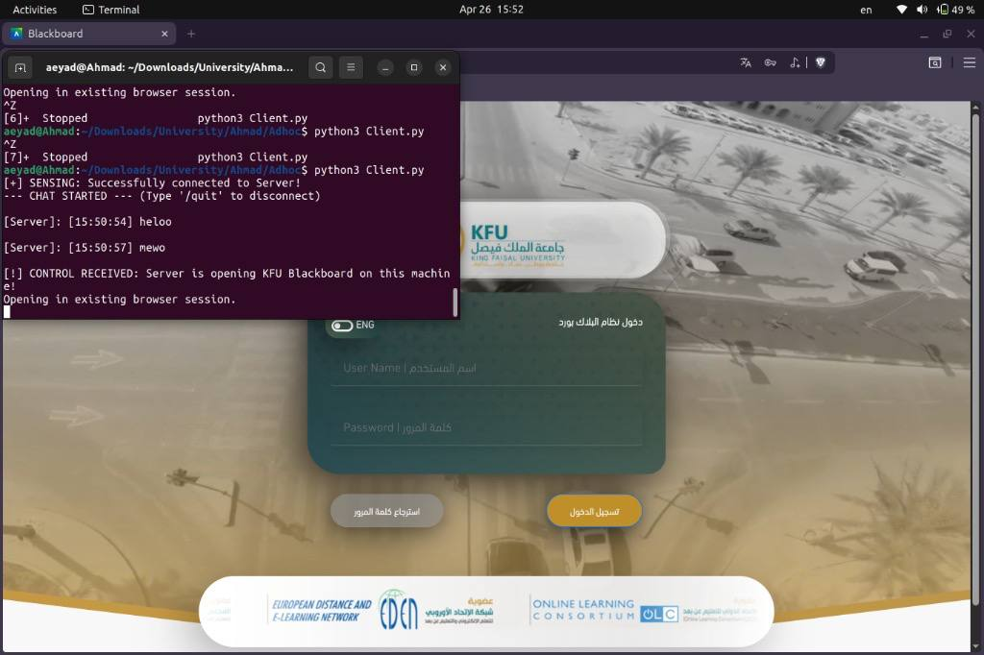
- Response from client device :

- Conclusion

In conclusion, this project successfully demonstrated the main ideas of an Ad Hoc network through a simple two-node system built with Python. The server and client were able to connect directly over LAN Wi-Fi without the need for a router or internet connection, which shows the basic advantage of Ad Hoc communication in small and flexible environments. The project also achieved the required functions of device discovery, real-time messaging, monitoring and remote control, making it a practical example of how Ad Hoc networks can support smart device interaction.

- Reference

Python Software Foundation. Python 3 Documentation

Python Software Foundation. socket

Python Software Foundation. threading

University or course lecture notes on Ad Hoc and Sensor Networks

